# Pert Chart for Project Prolang Master

The following table provides a comprehensive overview of the activities and their dependencies within the project. It visually represents the intricate relationships between various tasks, highlighting the dependencies that exist between them. As our project adheres to the Agile methodology, it is crucial to maintain a clear and organized structure, and therefore, a Pert chart is prepared for each sprint. This allows us to effectively plan and manage our tasks, ensuring that dependencies are properly identified and addressed, ultimately leading to a successful and timely project completion.

|  |  |  |
| --- | --- | --- |
| **Activities** | **Dependencies** | **Days Required** |
| Requirements Elicitation |  | 1 |
| Architecture Designing | Requirements Elicitation | 1 |
| Development | Requirements Elicitation, Architecture Designing | 2 |
| Test Case Designing | Development | 1 |
| Testing | Test Case Designing | 1 |
| Weekly Meeting | Testing | 1 |
| Next Sprint Plan | Weekly Meeting | 1 |

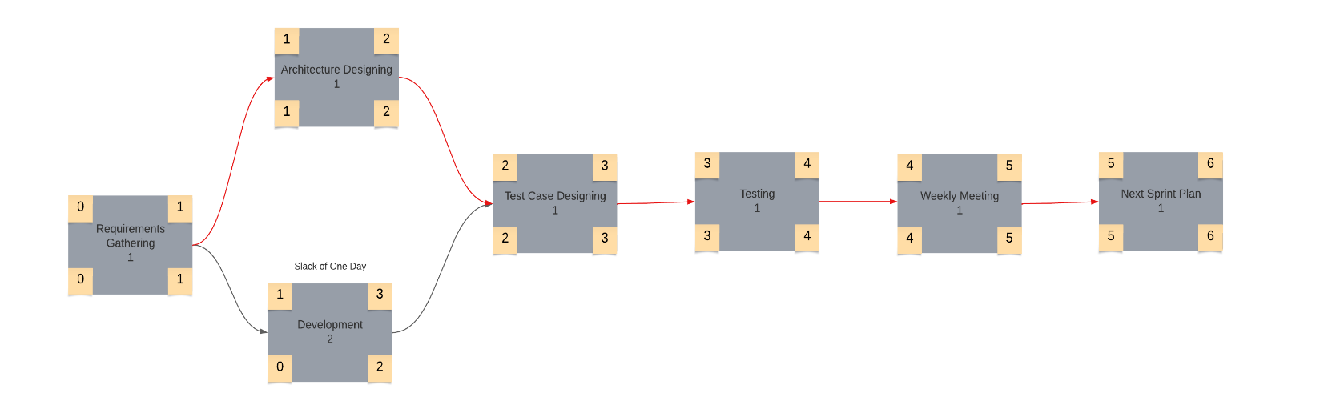

Figure : Pert Chart of Project

The Project has a slack time of one day. The critical path in highlighted with red.